1. Disadvantages of manual testing
2. Automation testing tools
3. Types of automation
4. Benefits of automation
5. Cost of Test Automation
6. Why Selenium
7. Pre requisite for automation
8. Test automation process

Disadvantages of manual testing:

1. Require more resources ( multiple browsers – FF ,Safari ,IE,Chrome)
2. It is time consuming ( understand req , create test cases , execute them , compare each test step actual and expected value )
3. Cross browser testing (Multiple os – windows , mac , linux)
4. Repeating test case with multiple test data
5. Less accuracy

Automation testing tools :

1. Selenium
2. UFT
3. Sahi
4. TOSCA
5. Appium
6. Selendriod

Functional: regression testing

Performance response time of the application under considerable load

1 user --- 1 sec

100 users --1.2 sec

200 users – 1.5 secs

Benefits of automation

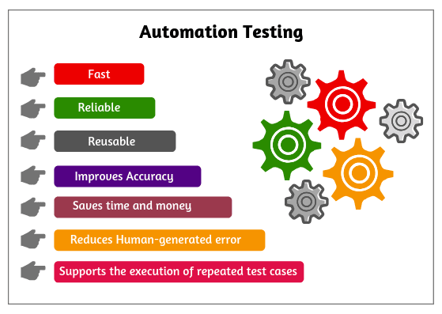

To set application with different set of data

Smoke test : when a new build / software is release to testing team , attest is run to verify if the build is stable to o detailed testing or not

BVT – Build verification test

Cost of Test Automation:

Cost of tool + labour cost for creating scripts+

Labour cost for script maintenance < manual effort then opt for automation

2 test cases -- every week for 2 years

2 \* 52 weeks = 104 times

2 test cases -- every week for 2 months

2 \* 8 = 16 times -- manual testing

Rules / Pre requisite for automation

1. Test environment should be stable
2. We should have access to application components
3. Execute manual test steps and determine results
4. Determine what data is required for test execution
5. Master data reset
6. Prioritize test case

100 manual test

70 test cases for automation

Test cases which are of high priority ( test cases where money transactions are involved)

Ex : Address --

Fund transfer

Smoke test BVT

Test case is data oriented (same test case with multiple sets of data)

Test cases which are taking longer time to execute manually

Multiple browsers (cross browser testing)

Multiple environments

Test automation process:

1. Define scope

What test cases we will automate

ROI

2

3.Procurment of tool

4. Train your team to use the tool

5.Identify automation framework ( POM, data driven , Keyword driven , BDD , TDD )

6. creation of automation scripts

7.Peer review

8. Execute scripts

9. Integration of scripts ( Sauce labs , ctest )

10 Script Maintenance

Why Selenium :

Selenium: Market leader

1. Open source
2. Multiple programming languages – Java , c# , java script , python , ruby
3. Multiple browsers

Multiple operating systems

Disadvantage:

Supports only web applications

Selenium Timelines :

2004 – Jason Huggins -- Thoughtworks --selenium core selenium 1.0

2006 –– Simon Stewart ---Google --web driver

2004 – selenium 1.0

2008 – (webdriver + RC ) – selenium 2.0

2016 – selenium 3.0

2021 - -selenium 4.0

Enhanced selenium Grid

Relative locators

Improved documentation

Why name selenium :

2004 – QTP --mercury

Selenium :

Open source

Run on different browsers

Run on all O.S

Supports mobile testing

No support for windows application

UFT :

Commercial

FF , IE , Chrome

Windows

HP Mobile centre

Supports windows